Project Design Phase-II
Technology Stack (Architecture & Stack)

Date | 29 September 2026
Team ID | SWTID-2026-5599
Project Name | AI Study Buddy
Maximum Marks | 4 Marks

Technical Architecture:
The Deliverable shall include the architectural diagram as below and the information as per the table1 & table 2
Example: Order processing during pandemics for offline mode.

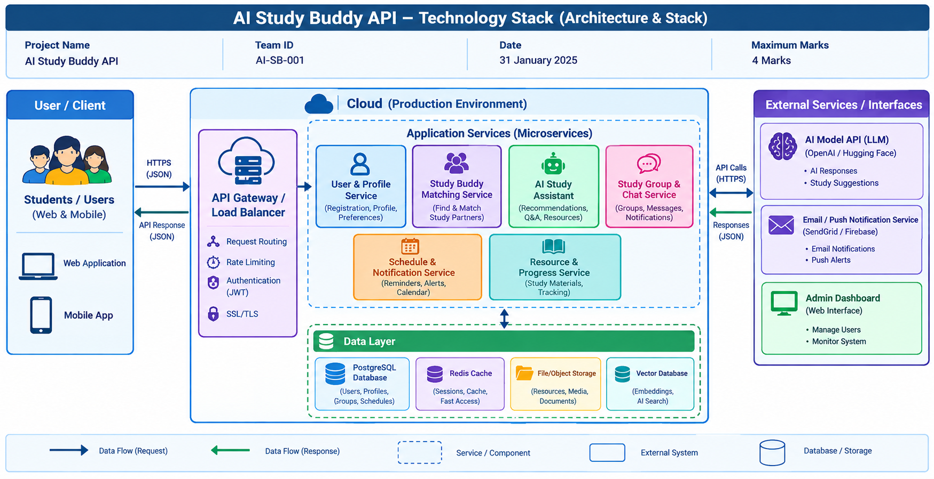

Table-1 : Components & Technologies:
S.No | Component | Description | Technology
 | User Interface | Interface through which students and administrators use the system. | React.js / Flutter, HTML, CSS, JavaScript
 | Application Logic-1 | Handles user registration, login, profiles, authentication and authorization. | Node.js + Express.js
 | Application Logic-2 |  | Python + FastAPI
  Handles AI study assistance, recommendations and study-buddy matching.
 | Application Logic-3 |  | Node.js + Express.js / WebSocket
  Handles study groups, chat, schedules, reminders and notifications.
 | Database | Stores users, profiles, groups, schedules, messages and study progress. | PostgreSQL
 | Cloud Database | Provides managed database services for the production environment. | Supabase / AWS RDS PostgreSQL
 | File Storage |  | AWS S3 / Cloud Object Storage
  Stores study notes, PDFs, images and other learning resources.
 | External API-1 | Provides AI-generated answers, explanations and study recommendations. | OpenAI API / LLM API
 | External API-2 |  | Firebase Cloud Messaging / SendGrid
  Sends email, push notifications and study reminders to users.
 | Machine Learning Model | Supports study-buddy matching, recommendations and semantic search using embeddings. | LLM + Embedding Model / Vector Search
 | Infrastructure (Server / Cloud) | Hosts and deploys the API and supporting services. | Docker, AWS / Azure / Render, Nginx

Table-2: Application Characteristics:
S.No | Characteristics | Description | Technology
 | Open-Source Frameworks | Frameworks used to develop the frontend, backend and API services. | React.js, Node.js, Express.js, Python, FastAPI
 | Security Implementations | Protects user accounts, API requests and personal data. | JWT, OAuth 2.0, HTTPS/TLS, bcrypt, RBAC
 | Scalable Architecture | Microservice-based architecture allows individual services to scale independently as users increase. | Docker, REST API, Kubernetes / Cloud Scaling
 | Availability | Keeps the API available with cloud hosting, health monitoring and service redundancy. | Cloud Hosting, Load Balancer, Health Checks, Monitoring
 | Performance |  | Redis Cache, PostgreSQL Indexing, CDN, Async Processing
  Improves response time using caching, optimized database queries and asynchronous API processing.

